**Melvin Vazquez-Andujar**

**Formula Sheet**

**Definition 3.11 – Poisson Distribution**

A random variable Y is said to have a Poisson probability distribution if and only if

Equation: $p\left(y\right)=\frac{λ^{y}}{y!}e^{-λ}$

**Theorem 3.11 – Expected and Variance of Poisson Distribution**

If Y is a random variable possessing a Poisson distribution with parameter λ, then

Expected: $μ=E\left(Y\right)=λ$

Variance: $σ^{2}=V\left(Y\right)=λ$

**Theorem 3.14 – Tchebysheff’s Theorem**

Let Y be a random variable with mean μ and finite variance σ 2 . Then, for any constant $k > 0$,

Equation: $P\left(\left|Y-μ\right|<kσ\right)≥1-\frac{1}{k^{2}} or P\left(\left|Y-μ\right|≥kσ\right)≤\frac{1}{k^{2}}$

**Definition 4.1 – Distribution function**

Let Y denote any random variable. The distribution function of Y , denoted by F(y), is such that:

Equation: $F\left(y\right)=P\left(Y≤y\right) for-∞<y<∞$

**Theorem 4.1 – Properties of a Distribution Function**

1.

2. .

3. F(y) is a nondecreasing function of y. [If $y_{1}$ and $y_{2}$ are any values such that $y_{1} < y_{2}$, then $F(y_{1}) ≤ F(y_{2}).]$

**Definition 4.2**

A random variable Y with distribution function F(y) is said to be continuous if F(y) is continuous, for $-∞ < y < ∞.$

**Definition 4.3 – Density function**

Let F(y) be the distribution function for a continuous random variable Y. Then f (y), given by:

Equation: $f\left(y\right)=\frac{dF(y)}{dy}=F'(y)$

wherever the derivative exists, is called the probability density function for the random variable Y .

**Theorem 4.2 – Properties of a Density Function**

If f (y)is a density function for a continuous random variable, then:

1.

2. .

**Theorem 4.3**

If the random variable Y has density function f (y) and a < b, then the probability that Y falls

in the interval [a, b] is

Equation: $P\left(a≤Y≤b\right)= \int_{a}^{b}{f\left(y\right)dy}$

**Definition 4.5 – Expected Value of random variable Y**

Equation: $E\left(Y\right)=\int_{-∞}^{∞}{yf\left(y\right)dy}$, provided integral exists

**Theorem 4.4**

Let g(Y ) be a function of Y ; then the expected value of g(Y ) is given by

Equation: $E\left[g\left(Y\right)\right]= \int_{-∞}^{∞}{g\left(y\right)f\left(y\right)dy}$

Provide integral exists

**Theorem 4.5**

Let c be a constant and let g(Y ), $g_{1}$ (Y ), g $g_{2}$ 2(Y ), . . . , $g_{k}$ (Y ) be functions of a continuous random

variable Y . Then the following results hold:

$E\left(c\right)=c$

$E\left[cg\left(Y \right)\right]= cE\left[g\left(Y \right)\right].$

$E[g_{1}(Y )+g_{2}(Y )+· · ·+g_{k}(Y )] = E[g_{1}(Y )]+E[g_{2}(Y )]+· · ·+E[g_{k}(Y )]$

**Definition 4.6 – Uniform Distribution**

If $θ_{1}$ < $θ_{2}$, a random variable Y is said to have a continuous uniform probability distribution on the interval ($θ_{1}$, $θ_{2}$) if and only if the density function of Y is:

Equation: $f\left(y\right)=\left\{\begin{aligned}\frac{1}{θ_{2}-θ_{1}}, θ_{1}≤y≤θ_{2} \\ 0, elsewhere\end{aligned}\right\}$

**Theorem 4.6 – Expected and Variance of Uniform Distribution**

If $θ_{1}$ < $θ_{2}$, and Y is a random variable uniformly distributed on the interval ($θ_{1}$, $θ_{2}$), then:

Equation for Expected: $μ=E\left(Y\right)= \frac{θ_{1}+ θ_{2} }{2}$

Equation for Variance: $σ^{2}=V(Y)= \frac{{(θ_{2}- θ_{1})}^{2} }{12}$

**Definition 4.9 – Gamma Distribution**

A random variable Y is said to have a gamma distribution with parameters α > 0 and β > 0 if and only if the density function of Y is

Equation: $f\left(y\right)=\left\{\begin{aligned}\frac{y^{α-1}e^{-\frac{y}{β}}}{β^{α}Γ(α)}, 0≤y≤∞ \\ 0, elsewhere\end{aligned}\right\}$

Where :

Equation: $Γ\left(α\right)=\int_{0}^{∞}{y^{α-1}e^{-y}dy}$

**Theorem 4.8 – Expected and Variance of Gamma Distribution**

If Y has a gamma distribution with parameters α and β, then

Equation for Expected: $μ=E\left(Y\right)=αβ$

Equation for Variance: $σ^{2}=V(Y)=αβ^{2}$

**Definition 4.11 – Exponential Distribution**

A random variable Y is said to have an exponential distribution with parameter β > 0 if and only if the density function of Y is

Equation: $f\left(y\right)=\left\{\begin{aligned}\frac{1}{β}e^{-\frac{y}{β}}, 0≤y≤∞ \\ 0, elsewhere\end{aligned}\right\}$

**Theorem 4.10 – Expected and Variance of Exponential Distribution**

If Y has a gamma distribution with parameters α and β, then

Equation for Expected: $μ=E\left(Y\right)=β$

Equation for Variance: $σ^{2}=V(Y)=β^{2}$

**Definition 5.1 – bivariate probability function**

Let $Y_{1}$ and $Y_{2}$ be discrete random variables. The joint (or bivariate) probability function for $Y_{1}$ and $Y_{2}$ is given by

Equation: $p\left(y_{1}, y_{2}\right)= P\left(Y_{1}= y_{1}, Y_{2}= y_{2}\right) -∞ < y_{1}< ∞, -∞ < y_{2}< ∞.$

**Theorem 5.1**

If $Y_{1}$ and $Y_{2}$ are discrete random variables with joint probability function p(, ), then

1.

2. where the sum is over all values ($y_{1}$, $y_{2}$) that are assigned nonzero probabilities.

**Definition 5.2 – bivariate distribution function**

For any random variables $Y_{1}$ and $Y_{2}$, the joint (bivariate) distribution function $F\left(y_{1}, y_{2}\right)$ is

Function: $F\left(y_{1}, y_{2}\right)= P\left(Y_{1}≤ y_{1}, Y_{2}≤ y_{2}\right) -∞ < y_{1}< ∞, -∞ < y_{2}< ∞.$

**Definition 5.3:**

Let $Y_{1}$ and $Y_{2}$ be continuous random variables with joint distribution function F($y_{1}$, $y_{2}$). If there exists a nonnegative function f ($y_{1}$, $y_{2}$), such that

Equation: $F\left(y_{1},y_{2}\right)=\int_{-∞}^{y_{1}}{\int_{-∞}^{y_{2}}{f(t_{1, }t_{2}){dt}_{2}}{dt}_{1}}$

for all $-∞ < y_{1} < ∞, -∞ < y_{2} < ∞$, then $Y_{1}$ and $Y_{2}$ are said to be jointly continuous random variables. The function f ($y_{1}$, $y_{2}$) is called the joint probability density function.

**Theorem 5.2**

If $Y_{1}$ and $Y_{2}$ are random variables with joint distribution function , then

1. .

2. .

3.

**Theorem 5.2 (In the textbook I have there is two Theorem 5.2)**

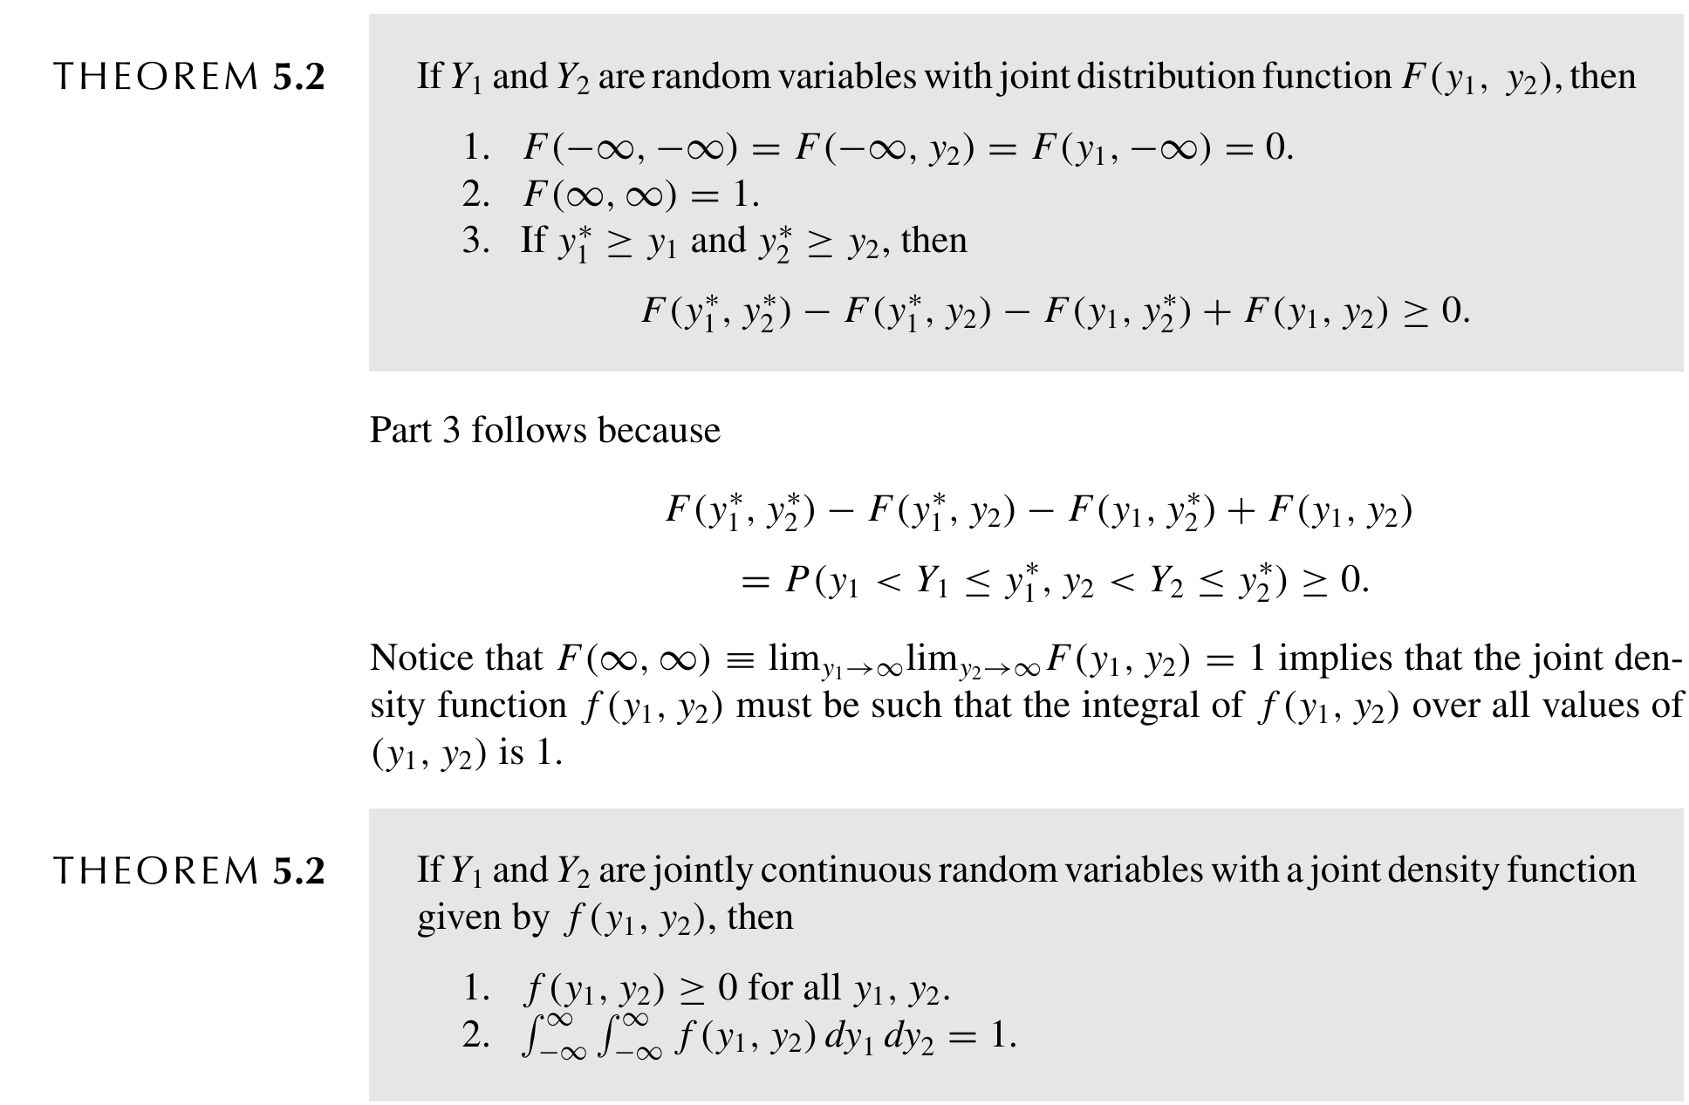

If $Y_{1}$ and $Y_{2}$ are jointly continuous random variables with a joint density function given by $f\left(y_{1}, y_{2}\right)$, then

1. $f\left(y_{1}, y_{2}\right), ≥ 0 for all y_{1}, y_{2}.$

2. $\int_{-∞}^{∞}{\int_{-∞}^{∞}{f (y_{1}, y_{2}){dy}_{1}, {dy}_{2}= 1.}}$

**Definition 5.4:**

$$p_{1}\left(y_{1}\right)=\sum_{all y_{2}}{p\left(y_{1},y_{2}\right)} and p_{2}\left(y_{2}\right)=\sum_{all y_{1}}{p(y_{1},y_{2})}$$

$$f_{1}\left(y_{1}\right)=\int_{-∞}^{∞}{f\left(y_{1},y_{2}\right)dy_{2}} and f_{2}\left(y_{2}\right)=\int_{-∞}^{∞}{f\left(y_{1},y_{2}\right)dy_{1}}$$

**Definition 5.5:**

If $Y_{1}$ and $Y_{2}$ are jointly discrete random variables with joint probability function $p\left(y_{1}, y_{2}\right)$ and marginal probability functions $p_{1}$ ($y_{1}$) and $p_{2}$ ($y_{2}$), respectively, then the conditional discrete probability function of $Y_{1}$ and $Y_{2}$ is

$$p\left(y_{2}\right)-P\left(Y_{2}=Y_{2}\right)=\frac{P\left(Y_{1}=y_{1}, Y_{2}=y_{2}\right)}{P\left(Y_{2}=y_{2}\right)}=\frac{p(y_{1},y_{2})}{p_{2}(y_{2})}$$

provided that $p_{2}\left(y_{2}\right)>0$

**Definition 5.6:**

If $Y_{1}$ and $Y_{2}$ are jointly continuous random variables with joint density function $f\left(y_{1}, y_{2}\right),$ then the conditional distribution function of $Y_{2}$ given $Y_{2}$ = $y_{2}$ is

$$F\left(y_{2}\right)=P(Y_{1}≤Y_{1}|Y_{2}=y_{2})$$

**Definition 5.7:**

Let $Y_{1}$ and $Y_{2}$ be jointly continuous random variables with joint density $f\left(y_{1}, y_{2}\right)$ and marginal densities $f_{1}$ ($y_{1}$) and $f_{2}$ ($y_{2}$), respectively. For any $y_{2}$ such that $f_{2}$ ($y_{2}$) > 0, the conditional density of $Y_{1}$ and $Y_{2}$ = $y_{2}$ is given by

$$f\left(y_{2}\right)=\frac{f(y_{1},y_{2})}{f_{2}(y_{2})}$$

and, for any $y_{1}$ such that f1($y_{1}$) > 0, the conditional density of Y2 given Y1 = $y_{1}$ is given by

$$f\left(y_{1}\right)=\frac{f(y_{1},y_{2})}{f_{1}(y_{1})}$$

**Definition 5.8:**

Let $Y_{1}$ have distribution function $F_{1}$ ($y_{1}$), $Y_{2}$ have distribution function $F_{2}$ ($y_{2}$), and $Y_{1}$ and $Y_{2}$ have joint distribution function F($y_{1}, y_{2}$). Then $Y_{1}$ and $Y_{2}$ are said to be independent if and only if

$$F\left(y_{1},y_{2}\right)=F_{1}(y_{1})F_{2}(y_{2})$$

for every pair of real numbers ($y_{1}, y_{2}$). If $Y_{1}$ and $Y_{2}$ are not independent, they are said to be dependent.

**Theorem 5.4:**

If $Y_{1}$ and $Y_{2}$ are discrete random variables with joint probability function $p\left(y_{1}, y_{2}\right)$ and marginal probability functions $p_{1}$ ($y_{1}$) and $p_{2}$ ($y_{2}$), respectively, then $Y_{1}$ and $Y_{2}$ are independent if and only if

$p\left(y_{1},y_{2}\right)=p_{1}(y_{1})p_{2}{(y}_{2})$ for all pairs of real numbers ($y_{1}, y_{2}$).

**Theorem 5.5:**

Let $y_{1}$ and $y_{2}$ have a joint density $f\left(y_{1}, y_{2}\right)$ that is positive if and only if a ≤ $y_{1}$ ≤ b and c ≤ $y_{2}$ ≤ d, for constants a, b, c, and d; and $f\left(y_{1}, y_{2}\right)$ = 0 otherwise. Then $Y_{1}$ and $Y_{2}$ are independent random variables if and only if

$$f\left(y_{1},y_{2}\right)=g\left(y_{1}\right)h(y_{2})$$

where g($y_{1}$) is a nonnegative function of $y_{1}$ alone and h($y_{2}$) is a nonnegative function of $y_{2}$ alone.